Kalman filter
for 1D motion : speed of the car = control input
aromas , H1, h2, h3 : landmarks : used for measurement correction
x_new = A*x_old + B*u + w
x_new : current state
x_old : previous state
A : state transition matrix
B : control input matrix
w : process noise (from a 0 mean normal distribution with covariance Q)

kalman filter :
what is the goal of using it ?
We are given the locations of aromas, H1,H2,H3, how do use them , for 1D motion? # we use it for measurements
Control input is : Velocity(randomized) or acceleration(randomized or fixed)
there are 2 options : either randomize the velocity or take constant acceleration
everything is assumed to be zero mean Gaussian
distribution
what will be the measurement equation ? Z = x +E ? (but this we use when there is like some gps system that is constantly providing the car’s location, that we consider as measurement)

write the prediction(propagate the state) and correction equations ?
What results do we obtain for the third gaussian distribution which is obtained by the multiplication of 2 gaussian distribution ; and given the mean and variance of those 2 gaussian distributions ??

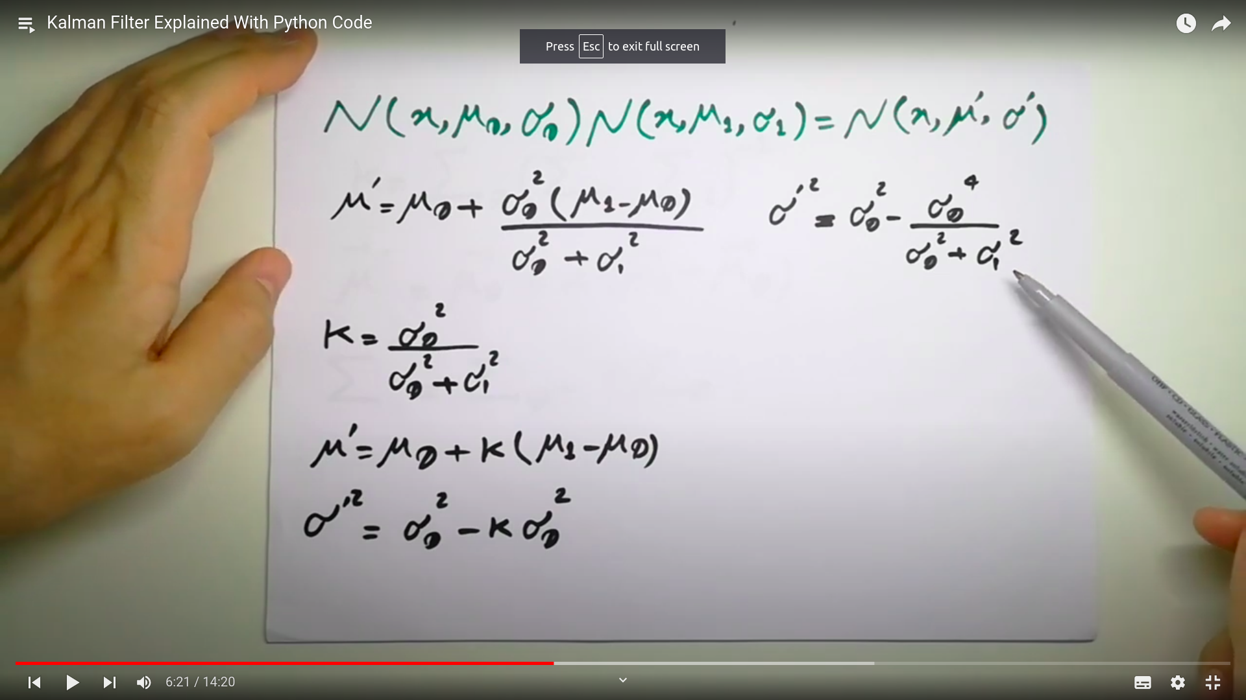
this is the ans ;(up)

what equations are used ?
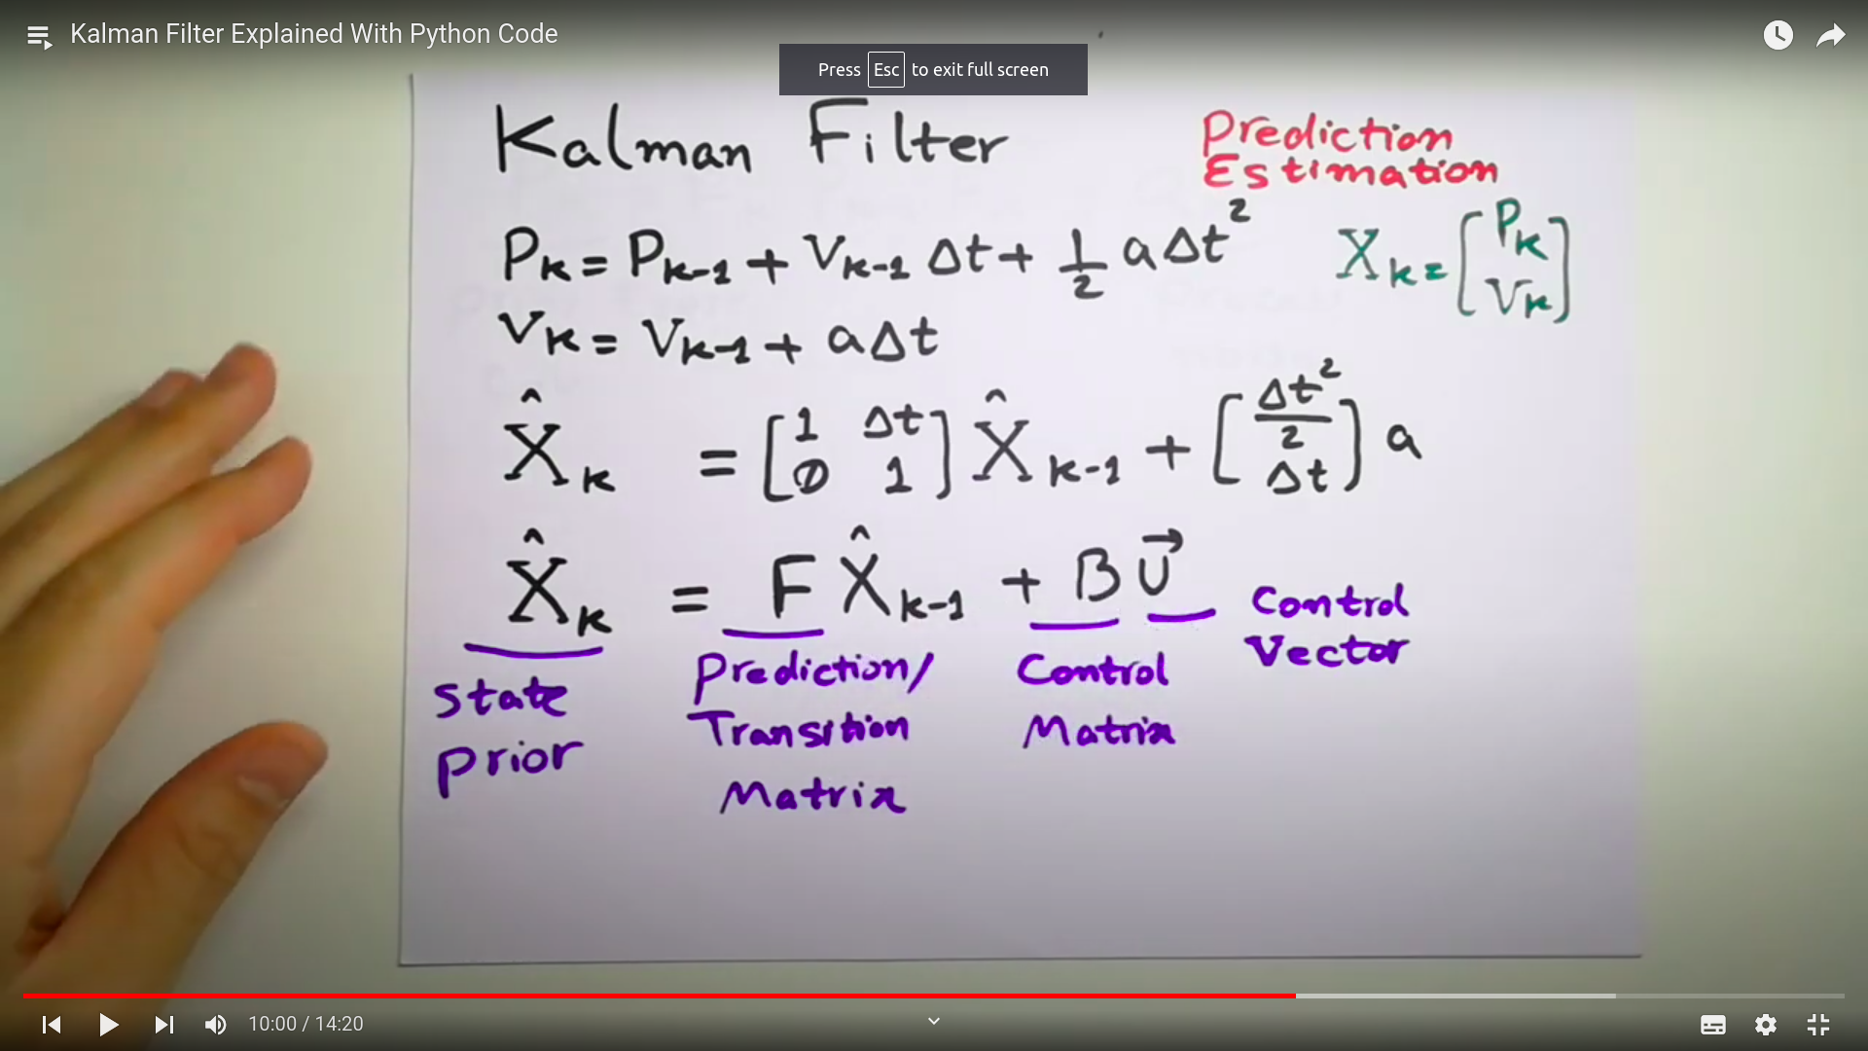
In the prediction state :

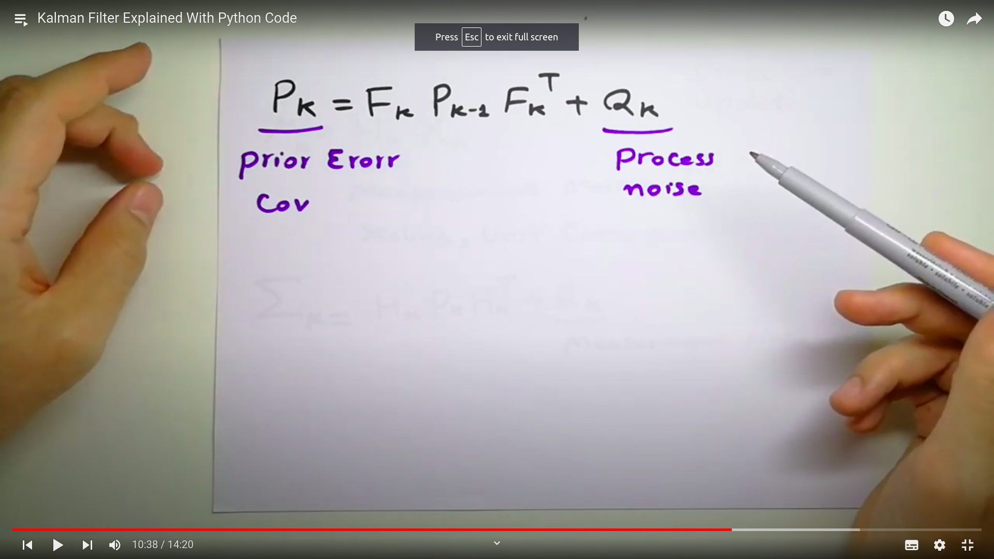

in the correction state :

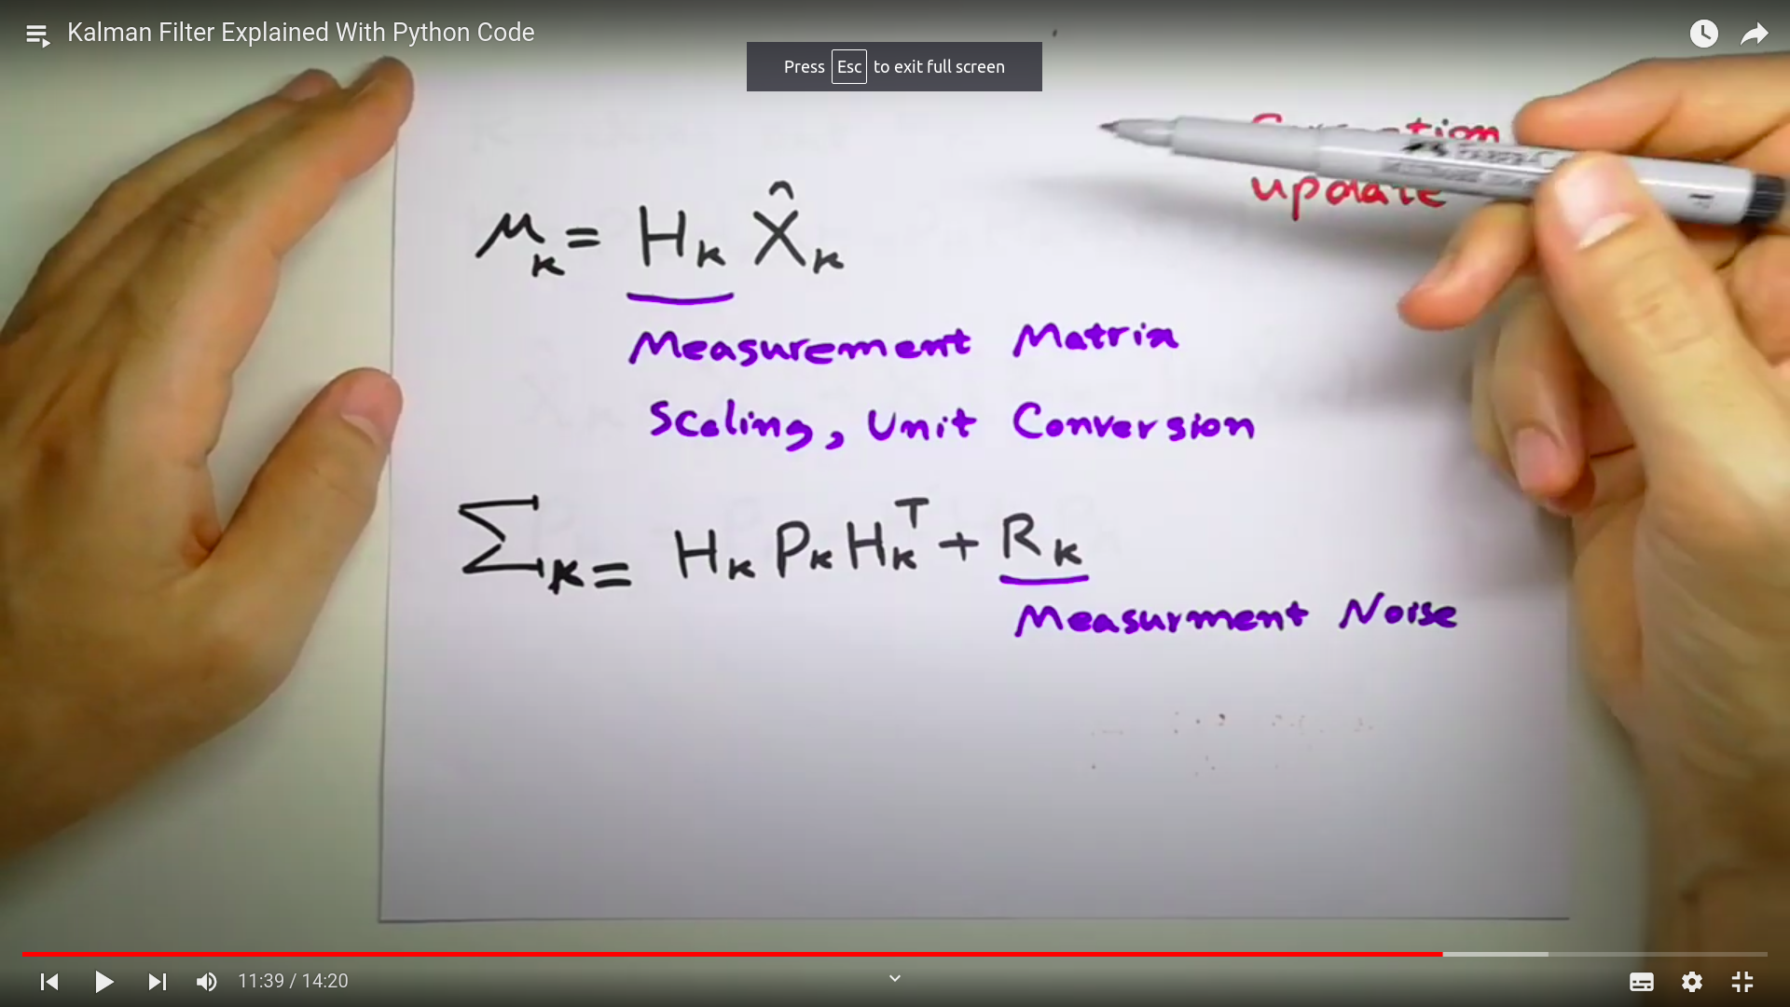

why do we import the library , scipy.stats.norm ?
For computing the normal gaussian distribution
how does the code match up with the frequency of the input data ?
Ans : it uses the if else conditions : like if the the measurement is available then run this , else not (see the code), if the measurement is not available then the filter relies only on the prediction step and not the correction step
what does landmarks mean ??
ans : locations where the measurement can be taken

KALMAN using the 1 hr video kalman and extended kalman given :

